Mini Project: Food Delivery Platform — Backend Database
Objective:
Build the complete backend database for a Food Delivery application, combining DDL, DML, JOINs, Views, and PL/SQL into a single integrated .sql script.
Your project must:
- Create three tables: restaurants (restaurant_id, name, city, cuisine_type, created_at), menu_items (item_id, restaurant_id, item_name, price, category) with a FOREIGN KEY on restaurant_id, and orders (order_id, customer_name, restaurant_id, item_id, quantity, total_amount, order_date) with a FOREIGN KEY on restaurant_id — all with appropriate PRIMARY KEY and NOT NULL constraints.
- Populate with at least 3 restaurants, 4 menu categories, and 15 order records distributed across restaurants.
- Create a VIEW named restaurant_sales_summary showing restaurant name, total number of orders, and total revenue grouped by restaurant.
- Write a stored procedure named add_order that accepts customer_name, restaurant_id, item_id, and quantity, calculates total_amount from the menu item price, validates the restaurant exists (ROLLBACK if not), and inserts the order record.
- Write a TRIGGER named after_order_insert that logs a record into an order_audit table (order_id, restaurant_id, action='INSERT', log_time=NOW()) immediately after every new order is created.
Answer:
CREATE DATABASE IF NOT EXISTS food_delivery_db;
CREATE TABLE restaurants (
restaurant_id INT PRIMARY KEY AUTO_INCREMENT,
name VARCHAR(100) NOT NULL,
city VARCHAR(50) NOT NULL,
cuisine_type VARCHAR(50) NOT NULL,
created_at DATETIME NOT NULL DEFAULT CURRENT_TIMESTAMP
);
INSERT INTO restaurants (name, city, cuisine_type)
VALUES
('Spice Villa', 'Ahmedabad', 'Indian'),
('Pizza Hub', 'Surat', 'Italian'),
('Dragon Wok', 'Vadodara', 'Chinese');

SELECT * FROM restaurants;
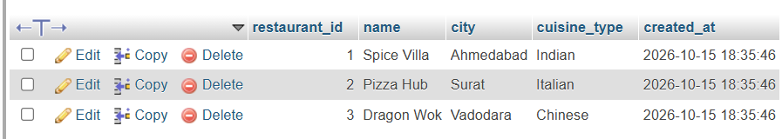

CREATE TABLE menu_items (
item_id INT PRIMARY KEY AUTO_INCREMENT,
restaurant_id INT NOT NULL,
item_name VARCHAR(100) NOT NULL,
price DECIMAL(10,2) NOT NULL,
category VARCHAR(50) NOT NULL,
FOREIGN KEY (restaurant_id)
REFERENCES restaurants(restaurant_id)
);
INSERT INTO menu_items
(restaurant_id, item_name, price, category)
VALUES
(1, 'Paneer Butter Masala', 250.00, 'Main Course'),
(1, 'Veg Biryani', 180.00, 'Main Course'),
(1, 'Samosa', 40.00, 'Starter'),
(1, 'Gulab Jamun', 60.00, 'Dessert'),
(2, 'Margherita Pizza', 220.00, 'Pizza'),
(2, 'Farmhouse Pizza', 320.00, 'Pizza'),
(2, 'Garlic Bread', 100.00, 'Starter'),
(2, 'Brownie', 90.00, 'Dessert'),
(3, 'Veg Hakka Noodles', 170.00, 'Main Course'),
(3, 'Manchurian', 150.00, 'Starter'),
(3, 'Spring Rolls', 120.00, 'Starter'),
(3, 'Ice Cream', 70.00, 'Dessert');

SELECT * FROM menu_items;
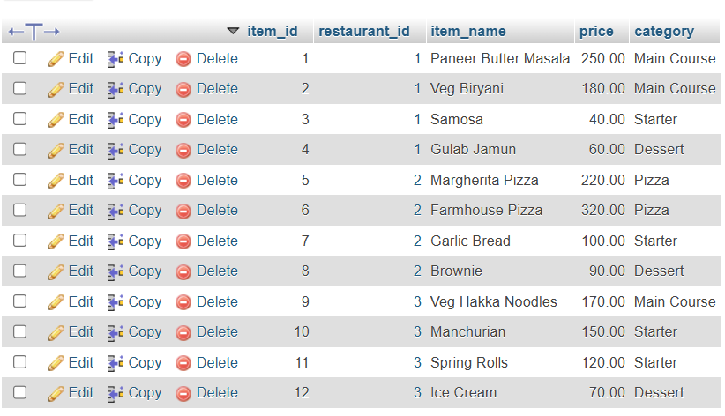

CREATE TABLE orders (
order_id INT PRIMARY KEY AUTO_INCREMENT,
customer_name VARCHAR(100) NOT NULL,
restaurant_id INT NOT NULL,
item_id INT NOT NULL,
quantity INT NOT NULL,
total_amount DECIMAL(10,2) NOT NULL,
order_date DATETIME NOT NULL DEFAULT CURRENT_TIMESTAMP,
FOREIGN KEY (restaurant_id)
REFERENCES restaurants(restaurant_id),
FOREIGN KEY (item_id)
REFERENCES menu_items(item_id)
);
INSERT INTO orders
(customer_name, restaurant_id, item_id, quantity, total_amount)
VALUES
('Aarav', 1, 1, 2, 500.00),
('Diya', 1, 2, 1, 180.00),
('Rohan', 1, 3, 3, 120.00),
('Meera', 1, 4, 2, 120.00),
('Kabir', 1, 1, 1, 250.00),
('Priya', 2, 5, 2, 440.00),
('Arjun', 2, 6, 1, 320.00),
('Isha', 2, 7, 2, 200.00),
('Dev', 2, 8, 3, 270.00),
('Anaya', 2, 5, 1, 220.00),
('Karan', 3, 9, 2, 340.00),
('Nisha', 3, 10, 1, 150.00),
('Rahul', 3, 11, 2, 240.00),
('Tara', 3, 12, 3, 210.00),
('Vivek', 3, 9, 1, 170.00);

SELECT * FROM orders;
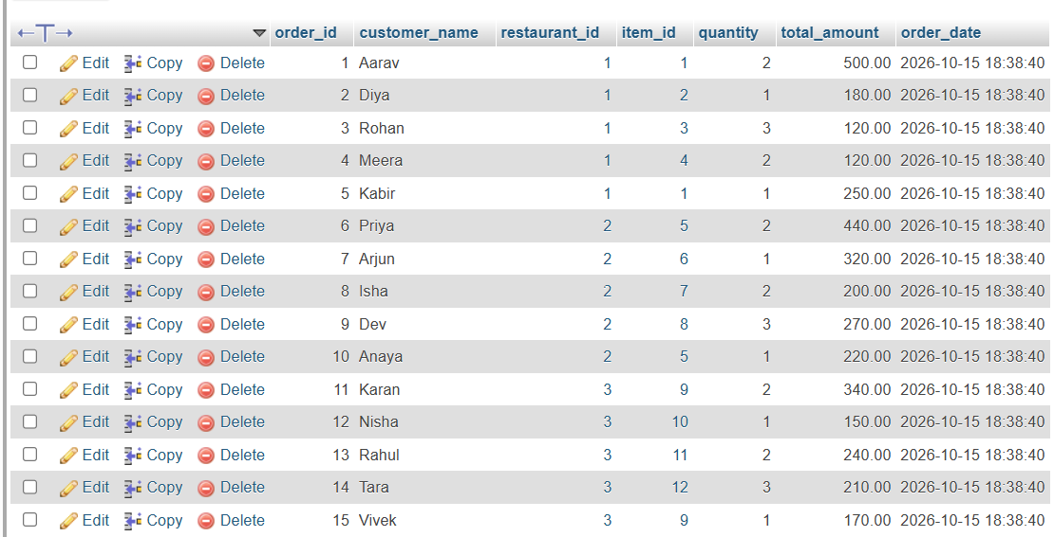

CREATE VIEW restaurant_sales_summary AS
SELECT
r.name AS restaurant_name,
COUNT(o.order_id) AS total_orders,
COALESCE(SUM(o.total_amount), 0) AS total_revenue
FROM restaurants r
LEFT JOIN orders o
ON r.restaurant_id = o.restaurant_id
GROUP BY r.restaurant_id, r.name;

SELECT * FROM restaurant_sales_summary;
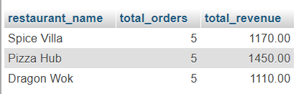

CREATE TABLE order_audit (
audit_id INT PRIMARY KEY AUTO_INCREMENT,
order_id INT NOT NULL,
restaurant_id INT NOT NULL,
action VARCHAR(10) NOT NULL,
log_time DATETIME NOT NULL
);
DESC order_audit;
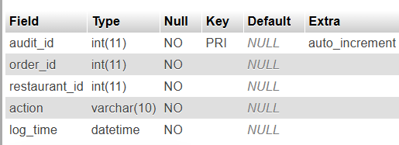

DELIMITER //
CREATE TRIGGER after_order_insert
AFTER INSERT ON orders
FOR EACH ROW
BEGIN
INSERT INTO order_audit
(order_id, restaurant_id, action, log_time)
VALUES
(NEW.order_id, NEW.restaurant_id, 'INSERT', NOW());
END//

DELIMITER ;

DELIMITER //

CREATE PROCEDURE add_order(
IN p_customer_name VARCHAR(100),
IN p_restaurant_id INT,
IN p_item_id INT,
IN p_quantity INT
)
BEGIN
DECLARE v_price DECIMAL(10,2);

DECLARE EXIT HANDLER FOR SQLEXCEPTION
BEGIN
ROLLBACK;
RESIGNAL;
END;

START TRANSACTION;

IF NOT EXISTS (
SELECT 1
FROM restaurants
WHERE restaurant_id = p_restaurant_id
) THEN
ROLLBACK;
SIGNAL SQLSTATE '45000'
SET MESSAGE_TEXT = 'Restaurant does not exist';
END IF;

IF p_quantity <= 0 THEN
ROLLBACK;
SIGNAL SQLSTATE '45000'
SET MESSAGE_TEXT = 'Quantity must be greater than zero';
END IF;

IF NOT EXISTS (
SELECT 1
FROM menu_items
WHERE item_id = p_item_id
AND restaurant_id = p_restaurant_id
) THEN
ROLLBACK;
SIGNAL SQLSTATE '45000'
SET MESSAGE_TEXT =
'Menu item does not belong to this restaurant';
END IF;

SELECT price INTO v_price
FROM menu_items
WHERE item_id = p_item_id
AND restaurant_id = p_restaurant_id;

INSERT INTO orders
(customer_name, restaurant_id, item_id,
quantity, total_amount, order_date)
VALUES
(p_customer_name, p_restaurant_id, p_item_id,
p_quantity, v_price * p_quantity, NOW());

COMMIT;

SELECT 'Order added successfully' AS message,
v_price * p_quantity AS total_amount;
END//

DELIMITER ;
CALL add_order('Neha', 1, 1, 2);
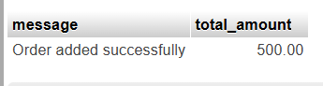

SELECT
o.order_id,
o.customer_name,
r.name AS restaurant_name,
m.item_name,
o.quantity,
o.total_amount,
o.order_date
FROM orders o
JOIN restaurants r
ON o.restaurant_id = r.restaurant_id
JOIN menu_items m
ON o.item_id = m.item_id
ORDER BY o.order_id;
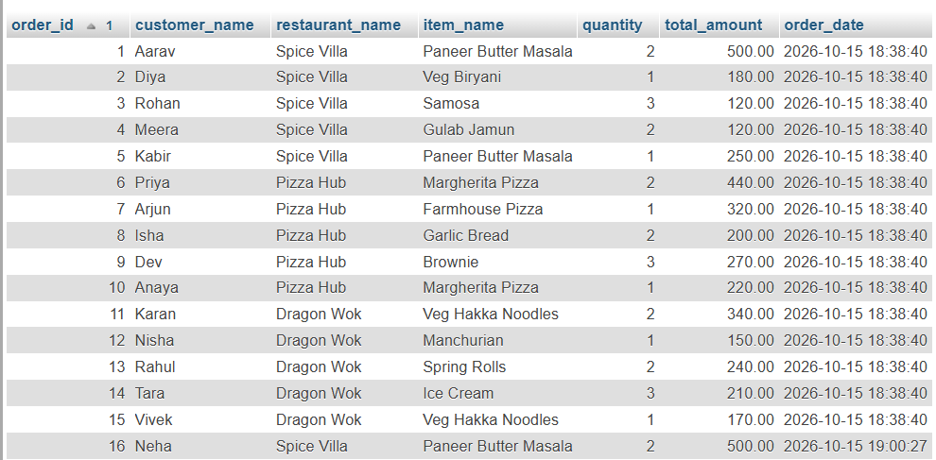

SELECT * FROM order_audit;


